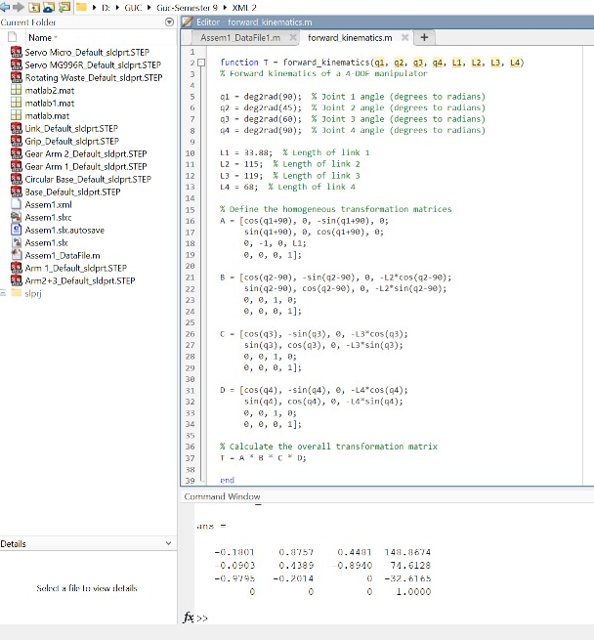

Arm 2 and arm 3 are given in the zip file grabbed from grabcad were added together to be a single part to decrease the number of Degrees of freedom. The arm will be the following:
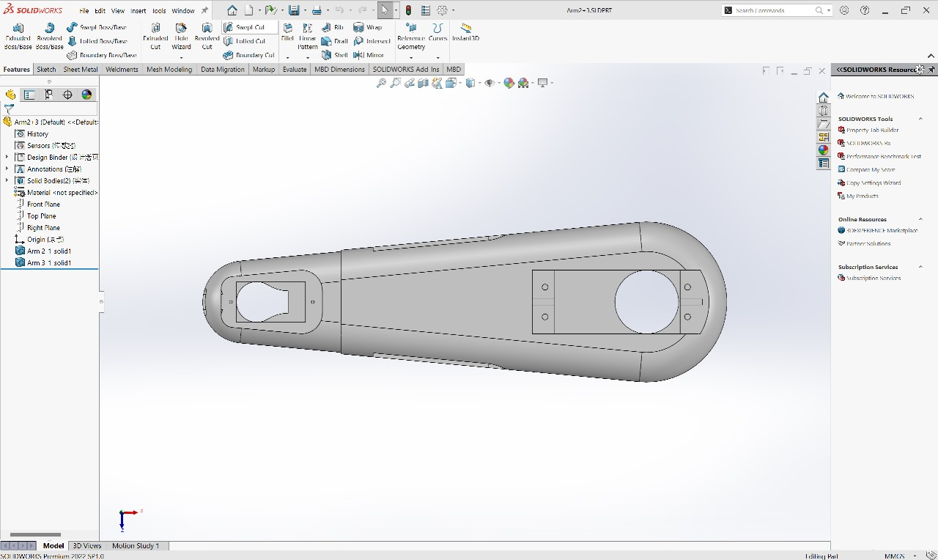

Hardware fabrication process : -
The hardware fabrication process for the robot began by importing the design from GrabCAD, which provided a solid starting point. However, slight modifications were made to customize the design according to the specific requirements of the project.
1. 3D Printing of Components:
- Links: After modifying the links for improved functionality and robustness, they were printed using durable, lightweight materials.
- Base: The base design was adjusted to better integrate the necessary electronics and provide enhanced stability for the entire system.
- Gripper: The gripper was designed for precision tasks, with fine details incorporated into the 3D-printed structure to allow for better manipulation of objects
Once the modifications were made, 3D printing was employed for quick and accurate prototyping. After printing, the components were inspected and assembled, ensuring that all adjustments fit together seamlessly for optimal performance.
